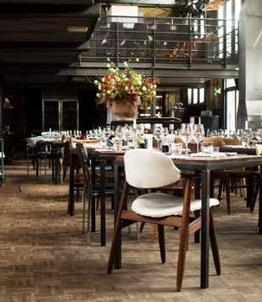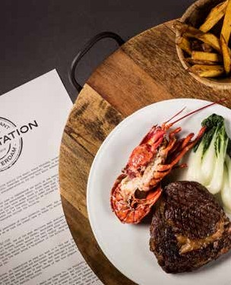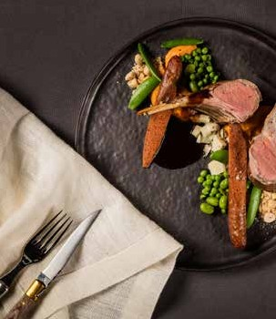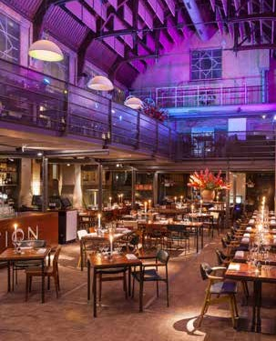

BAR RESTAURANT POMPSTATION BANQUETING BOOK

ENG

2019

INDEX

1 Introduction Bar Restaurant Pompstation 3

2 Finger Food & Open Bar 7

3 Bites Arrangement 9

4 Walking Dinner Menu 11

5 BBQ menu 16

6 Weddings 18

1

INTRODUCTION

ABOUT US

Bar Restaurant Pompstation is THE place for the dynamic, creative and cosmopolitan citizen of Amsterdam to wine, dine and enjoy special wines. After dinner you can
go dancing on Fridays and Saturdays. On Thursday through Sunday evenings, jazz musicians and upcoming bands perform live on a regular basis. You can also book artists for your event through us at favourable rates.

WINE & DINE

Pompstation has a menu with a good choice of meat types and also seasonal fish and vegetarian dishes. The prices of our special wines on the extensive wine list are calculated by a standard surcharge of 20 euros per bottle, allowing you to drink high quality wines at an attractive price.

UNIQUE LOCATION

The Pompstation (pumping station) was built at the beginning of the previous century (1912) after the fashion of the Amsterdam School. The three big pumps at the bottom of the basement are still being used by Waternet (the Amsterdam water company). The premises have an industrial feel that is very much like New York! In order to preserve the unique features of the 18 m (59 ft.) tall building, only pure and honest
materials have been used, such as glass, steel, tiles and Ipe hardwood. The entrance to
Bar Restaurant Pompstation is at 52 Zeeburgerdijk.

PARKING

You can park in the streets around Pompstation and this is from Monday till Thursday free after 21:00 hours and in the weekend (Friday and Saturday) after 00.00 hours. There is a large car park at Veemarkt, only several minutes away on foot. In addition, you can moor your boat close to Pompstation (at 100 metres distance) at a large landing stage.

TAILOR-MADE PROPOSAL

If you are planning a special occasion, party or event, we would love to think along with you. Please contact our event planners for this.

GENERAL INFORMATION

Pompstation is a great event location in Amsterdam for dinners, receptions & drinks, seminars, business meetings & presentations, weddings, congresses & corporate events.

CAPACITY

We have a loft and a general ground floor at Pompstation. We organise events from 30 up to 380 people.

LOCATION POMPSTATION

Capacity: 300m2
Length: 20 meter
Width: 10 meter
Height: 18 meter

AMOUNTS

Party outlook: 60-380 guests Theatre outlook: 50-140 guests Sit Down tables: 50-200 guests
Sit Down round tables: 50-175 guests

FOOD

Our very experencied and professional chef and her team can cook different meals for different settings. Food & events book on request.

FACILITIES

We have the following materials/settings available:
- Professional bar (1 loft/1 ground floor)
- Wardrobe facilities
- Wireless internet
- Outside garden
- Fully equiped sound system
- Modern Lightning technique
- Beamer/Video options

Please do not hesitate to contact our event planners in order to get you
aspecific proposal based on your own (or your clients) wishes.

LOFT BY DAY
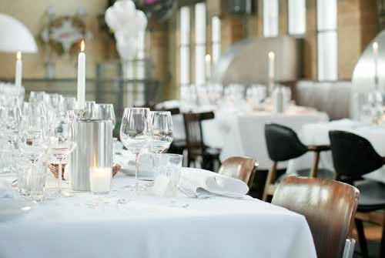

LOFT BY NIGHT
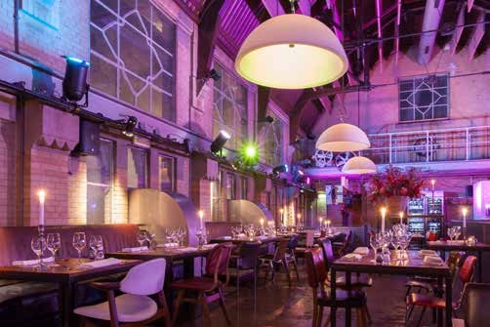

The loft can also be rented seperatly.

2

FINGERFOOD & OPEN BAR

CUTLERY € 4,75

Nuts
Marinated olives
Bread with aioli and pesto of sundried tomatoes

CHARCUTERIE € 9,95 per 2 pax

Pata negra, prosciutto, spinata romana and chorizo
Served with bread, aioli and pesto of sundried tomatoes

CHEESE PLATTER € 12,75 per 2 pax

Pompstation cheese platter with compote of vig

SNACKS € 7,00

Beef cheek croquette with mustard
Cheese sticks with sweet chili
Fries in cones with homemade mayonnaise
Dutch spicy spring rolls

OPEN BAR (DRINKS ON REDEMPTION)

Dutch bar (Heineken beer, wine, soda, water, coffee, tea, Dutch spirits)
- Costs: €8,00 per person per hour (minimum order is 4 hours)

International bar (Heineken beer, wine, soda, water, coffee, tea, Dutch spirits, strong drinks and mix drinks including: gin-tonic, bacardi-coke etc.)
- Costs: €15,00 per person per hour (minimum order is 4 hours)

Gin & Tonics

Various Cocktails:
For example Bombay Sapphire and lemon, or Tangueray with Grapefruit:
from €8.50 per cocktail

3

BITES ARRANGEMENT

BITES ARRANGEMENT from € 10,00

AMOUNT OF BITES PRICE

2 10,00 pp
3 15,00 pp
4 20,00 pp
5 25,00 pp
6 30,00 pp

Choose from the following appetizers:

VEGETARIAN

• Soup of chicory and carrot with creme fraiche and roasted almonds
• Crispy artichoke with purée of almonds and pesto of basil
• Beetroot and ricotta (or gorgonzola) wontons with pear-apple salad and
dressing of honey
• Eggplant-caviar on a crostini with goatcheese
• Quiche of broccoli and cauliflower with paprikacoulis and truffle-potato chips

MEAT

• Crostini topped with carpaccio and truffle mayo
• Bruscetta with Pompstation steak tartare
• Crostini topped with duck rillette and prune jam
• Baked black pudding with apple, union and gravy
• Creme brulee of duckliver and roots
• Pork belly with kabayaki lac and roasted sesame

FISH

• Prawn skewer with bernaise sauce
• Smoked salmon crostini with dill curd cheese
• Prawn/crayfish tartare with apple and wasabi crumble
• Tartare of seabass with chili, lime and wakame yuzu mayo
• Bisque with cream of cognac and chive

4

WALKING DINNER MENU

WALKING DINNER MENU from € 44,50

AMOUNT OF COURSES PRICE

5 44,50 pp
6 49,00 pp
7 53,50 pp
8 58,00 pp

Sample menu/ideas:

STARTERS

• Crispy artichoke with almond aioli and basil pesto
• Prawn/crayfish tartare with apple, fennel salad and wasabimayonaise
• Pompstation steak tartare with frisée and leaves of capers
• Soup of chicory and carrot with creme fraiche and roasted almonds
• Tartare of beet with goatcheese in panko and basil oil

MAIN DISHES

• Scottish salmon with a hot mustard crust on a leek and mascarpone risotto
• Thin sliced tournedos with crispy polenta, gravy and roasted mini tomatoes
• Mini hamburger of wagyu on a brioche with truffle mayonaise
• Baked sea bream with fennel salad and tarragon mousseline
• Spanish tortilla with sweet potato, manchego, chips of sweet potato and
puffed paprika mayonaise

DESSERT

• Lime-cream pie with vanille tuille
• Ganache pie with cantuccini crust
• White chocolate mousse with raspberrycompote, pistachio and choco shard
• Cheese supplement €3,50 p.p.
• Carrotcake with Dutch homemade cookie

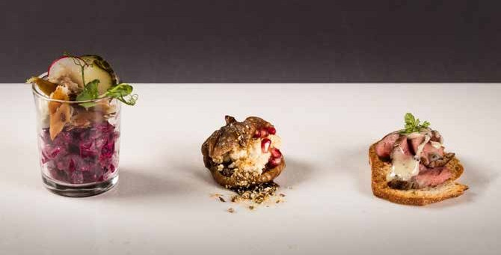

>>

ITALIAN FAMILY STYLE SHARED DINING from € 42,50

ANTIPASTO/STARTER (on etageres)

• Bread with olives
• Marinated artichokes
• Charcuterie of various sausages, proscuitto and salami
• Caprese salad with tomato, buffalo mozzarella and basil
• Grilled Mediterranean vegetables with rocket and vincotto
• Sundried tomato pesto

MAIN DISHES

• Tournedos with polenta mousseline, jus de veau and salsa verde
• Spaghetti with sundried tomatoes and burrata
• Linquini with sea bream, vongole and fennel salad
• Vegetarian ravioli of seasonal vegetables

DESSERT

• Ganache pie with cantuccini crust and limoncello gelly
• Scroppino

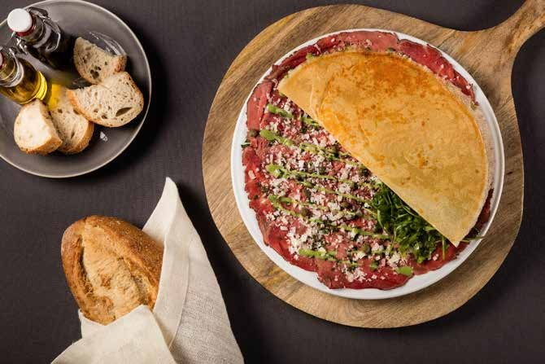

>>

THREE COURSES MENU € 39,00

Changing menu every month
Below are some sample menus:

1. CHEF’S BITES (no choice needed)

Beef cheek croquette with mustard aioli Witlof and carrot soup with toasted almonds Sole tartaar with wakame and salmon caviaar

MAIN DISHES

Holstein Hollands Ras tenderloin (150 gramme)
with date polenta, watercress salad and shallot jus

Or
Baked Seabass with green ratatouille, pumpkin puree,celeriac gratan and antiboise

Or
Spanish tortilla of sweet potato and manchego with sweet potato chips and beetroot
coulis

DESSERT

Tia Maria parfait with confit fig, honey mascarpone and biscotti crumble

Or
Scroppino

2. CHEF’S BITES (no choice needed)

Smoked salmon croquette with seed mustard Garden pea soup with mint and lemon gremolata Lamb Rillete with a date and orange jam

MAIN DISHES

Holstein Hollands Ras tenderloin (150 gramme) with roasted jerusalem artichoke,
rocket, pecorino and truffle oil

Or
Panfried fish of the day with Beluga lentils, saffron velouté, carrot and celeriac
antiboise

Or
Roulade of savoy cabbage filled with ricotta, tarragon, pumpkin and pistachios on a
truffle potato puree and a white balsamic syrup

DESSERT

>>

Bread and butter pudding with Baileys and banana, cinnamon creme anglaise and crisp wafer

Or
Scroppino

3. CHEF’S BITES (no choice needed) Duck and Goose rillette with prune jam
Baby squid arancini with saffron aioli
Soft leek and mascarpone flan with a parmesan paprika crumble

HOOFDGERECHTEN

Holstein Hollands Ras tenderloin (150 Gram) with winter purslane parsnip puree and marsala star anise jus

Or
Roast Monkfish fillet with a celeriac puree, brussel sprouts, pancetta and chestnuts

Or
Millefeuille of mushrooms and truffle with lemon jam, wilted baby spinach and
balsamic syrup

DESSERT

Walnut and honey parfait with cherry compote

Or
Scroppin
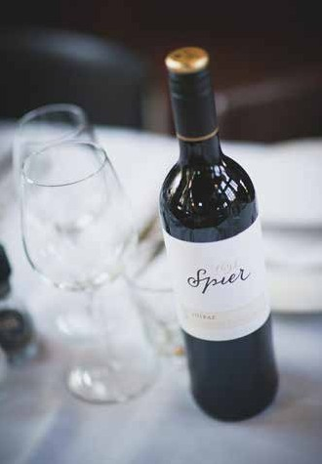
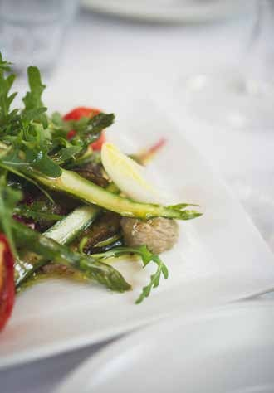

6

WEDDINGS

Yes, I do!

Pompstation is an official location for getting married, and we are proud of that! We allow all aspects of a marriage, from a ceremony and reception to a splendid dinner and party. Pompstation also has a beautiful, large enclosed garden.

DINNER & PERSONAL GUIDANCE

Pompstation can offer you guidance in organizing your marriage, and we pay special attention to putting together the right snacks & drinks for a reception, or the menu for a wedding dinner.

Together with our chef it is possible to draw up a menu, tailored to your needs. We have extensive experience of both sit-down dinners and walking dinners.

PARTY

Since we have live music at Pompstation every Thursday through Sunday, you can book artists, bands or DJs via our music agent at attractive prices.

We have many years of experience in organizing a splendid wedding party, and on
Fridays and Saturdays you can party on until 3 o’clock at night!

OVERVIEW OF HALLS

Name of hall Ceremony Reception Dinner Party

Downstairs hall 130 250 130 250 people
Upstairs, loft 80 120 80 120 people

